

**HAPPIEST MINDS TECHNOLOGIES**

Requirement Overview for Adobe Storefront-V1



Contents

1 INTRODUCTION 4

2 STOREFRONT REQUIREMENTS 4

2.1. Overview 4

2.2 Workflow of Storefront 4

2.3 Basic Flow of Learner 5

2.4 Basic Flow of Admin 5

2.5. Functionalities 6

2.5.1 `Listing of Courses 6

2.5.2 Listing of Catalogues 8

2.5.3 View Course Details 9

2.5.4 Search and Discover Courses and Catalogs 10

2.5.5 User Profile Management (TBC) 12

2.5.6 Authentication to Storefront (via Single Sign On) 13

2.5.7 Course Subscription/Registration and Make Payment 14

2.5.8 Admin Activities 15

2.5.9 Admin Dashboard 15

2.5.10 Marketing Module (TBC) 16

2.5.11 Synchronization of Data 16

2.5.12 Extra Features 16

2.5.13 Role based access to Storefront 17

2.5.14 Securities & Confidentiality 17

2.5.15 System Integration 17

2.5.16 Localization/Customization 17

3. Features and Business Rules 18

3.1 Authentication to Storefront 18

3.2 User Profile Management 21

3.3 Listing of Courses in Storefront 22

3.4 Listing of Catalogs in Storefront for a Learner 23

3.5 View Course Details 24

3.6 Search and Discover Courses and Catalogs 25

3.7 Course Subscription by Learners 26

3.8 Payment Activities 26

3.9 Admin Activities 27

3.10 Admin Dashboard 27

3.11 Notifications 27

3.12 Help/contact us 29

3.13 Marketing Module 29

4. Notes 29

# INTRODUCTION

Adobe Captivate Prime (ACP) is a next-gen Learning Management System (LMS) that delivers personalized learning experiences across multiple devices. Align all online and offline enterprise-wide learning initiatives to skill, upskill and reskill the employees. Currently, ACP does not have any provisions for eCommerce services like buying course or selling courses. Adobe Captivate Prime requires a platform which can have provisions for required eCommerce services.

Storefront is an eCommerce solution, using which user will be able to browse, review and subscribe to available courses. Once subscribed, she/he can view the course content from Adobe Captivate Prime.

# STOREFRONT REQUIREMENTS

## 2.1. Overview

The Storefront application will act as web interface in between the Adobe Captivate Prime and users. It offers all basic features of a LMS as well as eCommerce services to its users.

The actors will be able to access the system according to their authorization and permissions available to them to use and view information from the system.

## 2.2 Workflow of Storefront

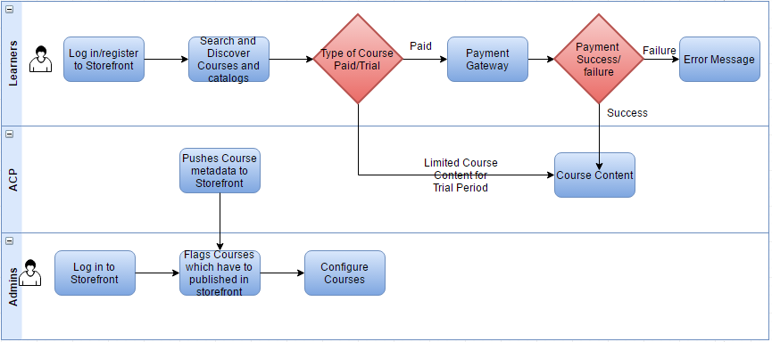

## 2.3 Basic Flow of Learner

Search and Discover Courses

Catalogues and Courses

Register/Login

Subscribe to Courses(Paid/Trial)

View Course details

Consume Courses from ACP

## 2.4 Basic Flow of Admin

Course Metadata from ACP to Storefront

ACP Admin

Admin logs in and flags courses that have to published in storefront

Storefront

Admin

Successful Payment and provide provision to access the course

List the Course for the Learner

Configure Course s(pricing/discounting)

## 2.5. Functionalities

Storefront application can be accessed by different types of Users based on their roles. Users can be classified as Learners and Admin users.

Learners are those who will subscribe to courses and read courses in Captivate Prime

Admin users are those who can configure course details and its payment related details.

Customers of Captivate Prime can publish their content in Prime and will have provision to configure their courses in Storefront. These types of users also will be considered as Admin users.

The main functionalities of Storefront application is;

* + - Listing of Courses
    - Listing of Catalogues
    - View Course Details
    - Search and Discover Courses
    - User Profile management
    - Authentication
    - Course Subscription/Registration and Make Payment
    - Admin Dashboard
    - Marketing Module
    - Migration Module
    - Extra Features (Notification, Help, etc.)
    - Role based access to system

### Authentication to Storefront (via Single Sign On)

Storefront users will get redirected to ACP for authentication. User should be able to view Storefront home page after successful authentication.

Storefront maintains Single Sign On session with Prime. This enables user to get redirected to Prime without any additional login or explicit authentications. Single Sign on feature helps different actors in the system to integrate with Adobe Captivate Prime

The following are the features of account registration;

* ~~Storefront Users should be able to login using with user name /password~~
* ~~All Users should be able to retrieve forgot password~~
* ~~All Users should be able to synchronize authentication details with Adobe Captivate Prime~~
* ~~Admins Should be able to login by using the registered Adobe Prime Account credentials~~*~~(TBC)~~*
* ~~Learners should be able to launch Storefront using the secure link received by welcome e-mail for the first time (free registration)~~ *~~(TBC)~~*
* System should be able to take Storefront Users to ACP log in page after loading the Storefront URL.
* After successful log in the users should be able to view the storefront homepage.
* All the authentication related features (eg. forgot password) should be handled by ACP.

**Queries**

1. How to manage profiles across ACP and storefront?

### Listing of Courses

The Storefront UI displays the different courses under catalogs. The Listing of Courses functionality includes following features;

* Storefront System should be able to pull all course meta data information from ACP offered for that organization
* Storefront should list all Courses that are tagged to be offered for trial/purchase for that organization.
* Storefront should be able to display the default course list after first login for Learners
* Storefront should be able to manage additions, modifications and deletions of courses
* Storefront should be able to identify and display Courses as per the Learner’s previous subscription history/preferring for Learners under Recommended Courses
* Storefront should provide brief course details like Course name, content details, rating, author details, demo videos, course type (paid/free), bookmark, add to playlist, related courses, review by the people, etc. along with the courses under each category (trending courses/recommended courses/ all courses)
* Storefront should provide different view options like grid view/tile view for the courses.
* Learners should be able to view Ongoing Courses which they have already started consuming along with percentage of completion, Course Name, etc.
* Learners should be able to view the Trending Courses.
* Storefront system should be able to list newly added courses under different tab in the home screen
* Admin users need to be able to flag which courses or catalogues need to be published for learners
* Admins should be able to configure their courses also before listing into storefront.
* Admin should be able to view other admins published courses through storefront.
* Admins should be able to view the trending courses in the admin portal
* storefront (as part of course import) has to interpret this as one course with 2 different offerings – trial and full version.
* Storefront system should be capable of doing internally mapping of user to the respective user group in ACP needs to be triggered from storefront in case of trial/purchase courses
* Courses offered as class room – should have max seats configured and storefront will do a checking of whether seats are available for registration

**Listing of Courses for a learner**



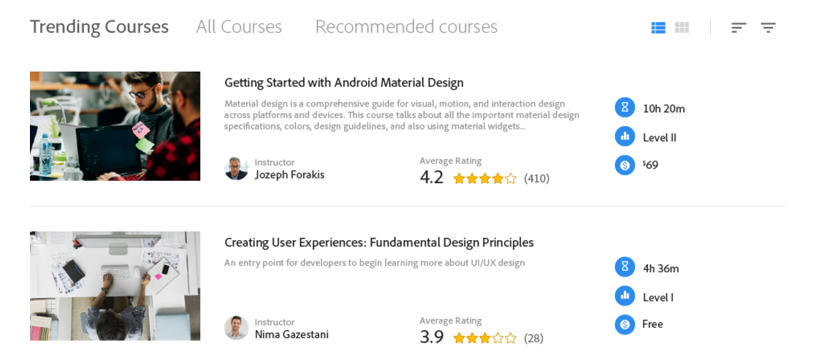

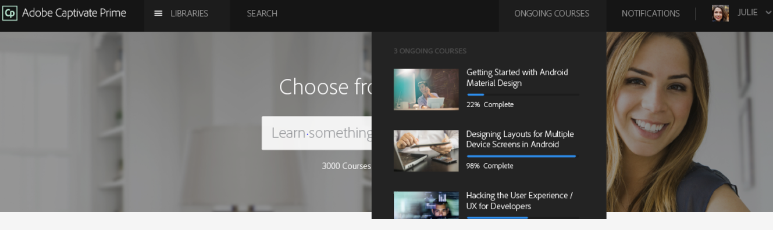

**UX mocks for Listing of courses for Admins have to be prepared

**Queries**

1. As there is no category for courses in ACP, how will we provide the categories(programming/businesses/etc)

### Listing of Catalogues

Catalog should include all learning programs, certifications, courses for the learner role. These learning objects are unique to each learner based on his role, designation, user group, profile, and so on.

The following are the features of Listing of Catalogs.

* Learners can view all the assigned and eligible learning objects (learning programs, courses and certifications) under Catalogs.
* Learners should be able to filter catalogs based on:
* Type of learning (Self-paced/Classroom/Virtual/activity)
* Skills *(Parked for next release)*
* Learning Objects (Courses, learning programs, certifications, job aids)
* Completion status
* Storefront should be able to display courses under default catalog for the Learners.
* System should be able to provide access certification for the user fetching the same from ACP
* There should be a search bar on top of the page to enter the names of your familiar learning objects.
* A learner should be able to access gamification/badges/skis after the completion of courses *(Parked for next release)*

### View Course Details

Course Detail page should include the following functionalities;

* Storefront should be able to display the course details like Course name, content details, rating, author details, demo videos, option to enroll the course(paid/free), bookmark, add to playlist, related courses, review by the people, etc. for all Users
* Learners can enroll/subscribe for the course after reading the details.
* System should take the learner to the payment option if it is a paid course
* System should provide option to provide rating after the successful completion of the course.
* Admins should be able to view the course details like Course name, content details, rating, author details, videos, option to configure course(paid/free), etc. which are published only by them.
* Admins should be able to configure the courses through the admin portal

**View Course details by a Learner**



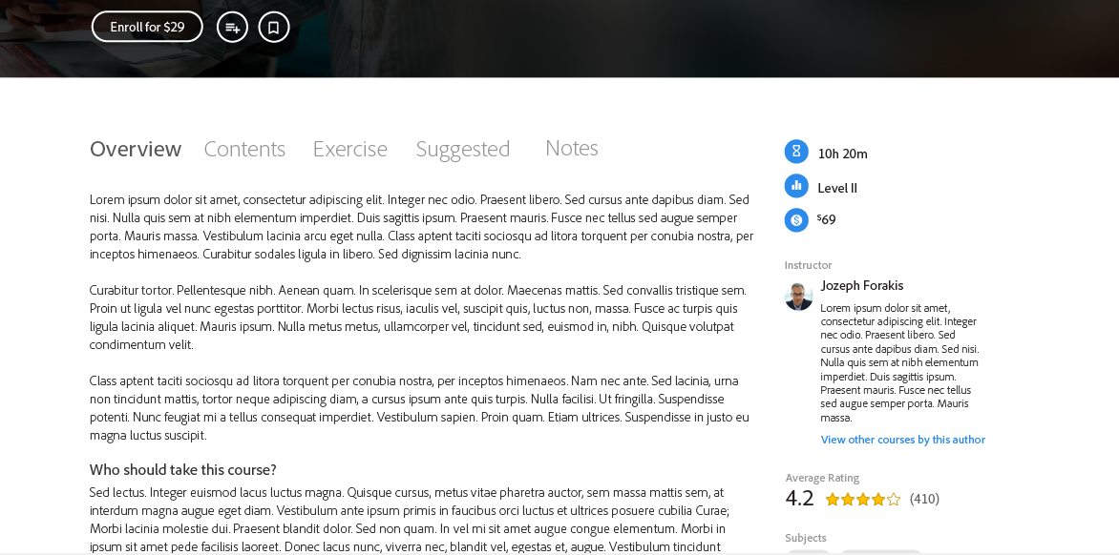

**UX mocks for Listing of courses for Admins have to be prepared.

### Search and Discover Courses and Catalogs

Search and Discover Courses provides the following functionalities to users

* Storefront can provide parameterized search through elastic search
* All Storefront Users should be able to search Courses based on
  + topic
  + subtopic
  + rating etc.
* All Storefront Users Should be able to Sort based on
* Total Hours
* Price
* Popularity
* Rating
* Most Enrolled
* Most Recent
* Learners should be able to filter Courses based on
* Category
* Course Type
* Payment
* Learning Programs
* Certifications
* Status (Yet to start/ Progress/ Completed)
* Skills (General/ Skill based) *(parked for next release, TBC)*
* Competency *(parked for next release, TBC)*
* Authors/Instructors
* Admins should be able to filter their Courses based on;
* Category
* Course Type
* Payment
* Competency *(parked for next release, TBC)*
* Learners should be able to filter the catalogs based on
* Type of learning (Self-paced/Classroom/Virtual/activity)
* Skills
* Learning Objects (Courses, learning programs, certifications, job aids)
* Completion status
* System should provide Course effectiveness, skill based/competency based searches and course effectiveness index *(Parked for next release)*

**Search option for Learners**

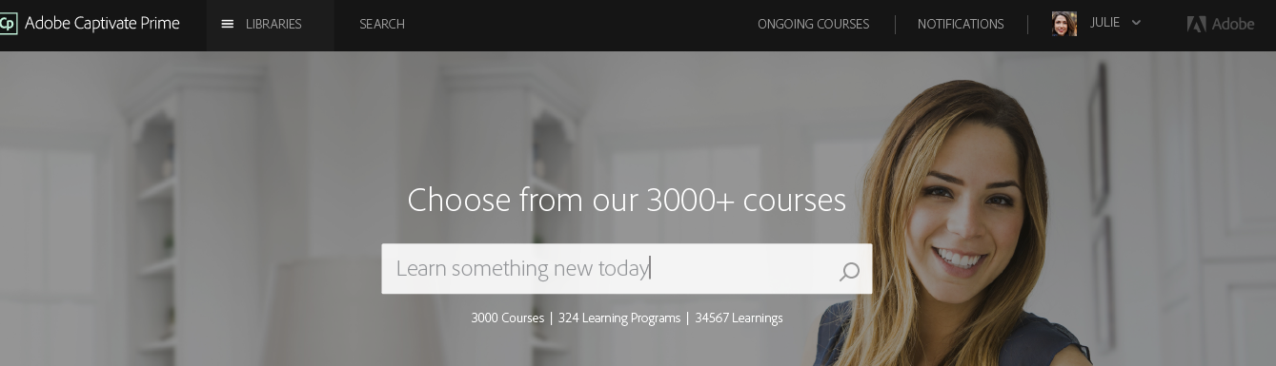

**Filter and Sort options for Learners**

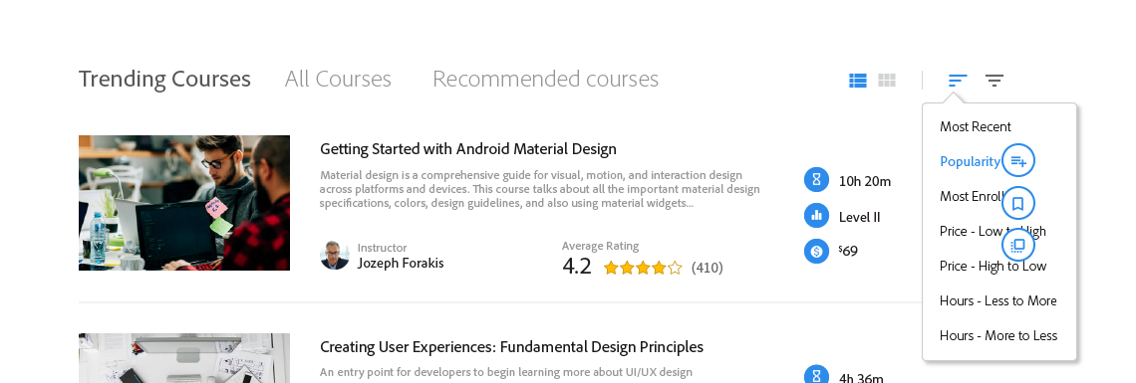

**UX mocks for Search and Discover courses for Admins have to be prepared.

### User Profile Management (TBC)

* Storefront users should be able to manage user information (user name/email id/contact number/password) directly from ACP
* Membership details of the Users will be managed by ACP
* Learners should be able to view subscribed courses details like;
* Course Name
* Course Progress Bar
* Subscription end date
* Payment details
* Purchase History
* Learners should be able to delete the account
* Learners should be able to download transcript sheet to quickly get some overall data for his/her learning profile. *(Available feature in ACP)*
* Learners should be able to view the Play list/ Bookmarked courses.
* Storefront system should be able to store preferring/likings of the Learners. Recommended courses will depend only on previous subscription
* Learners should be able to view the statistics attributes like
* Rating given
* Recently watched courses
* Recently searched and views courses
* Learners should be able to edit the payment details (eg. change card type)
* Learners should be able to update include the following
* Set the Locale for your profile. From the Locale, drop-down select the language of your choice.
* Set the Current Locale for your profile.
* Set the Time Zone for your profile.

**Profile management by Learners**

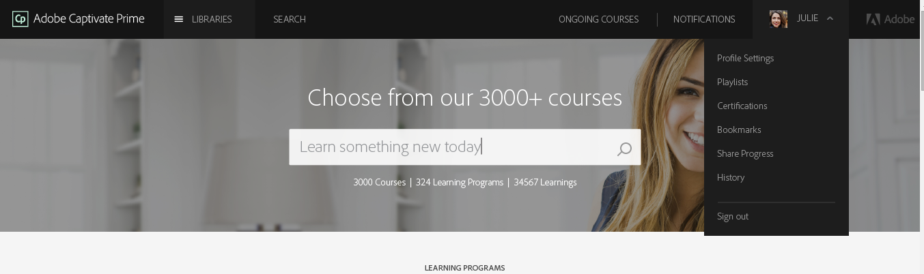

**UX mocks for Admin Profile management have to be prepared.

### Course Subscription/Registration and Make Payment

The courses are subscribed by Learners from Storefront. Storefront will provide a provision to Learners to register for a course on trial basis or purchase a course. Once user subscribes to a course, user is ready to consume a course. Then Storefront will redirect Learners to Adobe Captive Prime to enable them to consume courses.

The following are the required functionalities for Learner;

* Storefront system should handle all subscription related data of the Learners.
* Learners should be able to view the Subscription options for course
* Should be able to Subscribe for a course on trial basis
* Learners should be able to get notification related to expiry of trial period/subscription/renewal etc.,
* Should be able to purchase the course after the trial period
* Should be able to view the Discounts/ offers/early bird, etc.
* Learner should be able to upgrade a trial course to a registered one
* Should be able to make the payment through the payment gateway (debit/credit/PayPal)
* System should provide EMI option (not an immediate functionality. But can configure payment plan)
* Should be able to add to cart
* Should be able to View/Edit the cart
* Should be able to add Courses to Wish list
* System should be capable of cancellation of the payment of courses/reimbursement of money/valet options.
* System should be capable of associating the respective group to Prime.
* System should provide link to course material (Clicking on it will take user to Course content in ACP) after completing successful payment if the course is a paid one
* Storefront should be able to provide an option to provide rating after competition of the course.

**For MVP, Storefront will be a light weight product and Storefront won’t handle Subscription related validations of learner.

### Admin Activities

Admin users are those who can configure course details and its payment related details. The following are the required features;

* In case of trial course, admin can configure trial period of the course
* Should be able to provide prices for each course
* Should be able to edit the Course Type(paid/free) and to renew the prices for each course
* Should be able to receive the payments and provision to consume the course from Adobe Captivate Prime
* Should be able to prevent the Learner from consumption of the courses after the expiry of the trial/subscription
* Should be able provide discounts, Offers (Eg. early bird, rewards)
* Should be able to View Trial Account Conditions
* Time period limit
* Content view limitation
* Maximum number of trial a learner can enroll to
* Track learner behavior on trial course
* Admins should be able to delete their account.
* Admins should be able to view the history of their configured course types
* Admins should be able to access the learner details through Admin portal
* Admins should be able to view the most enrolled courses among their published courses
* Admins should provide assistance to Learners queries *(Chatbot is an option. TBD)*

### Admin Dashboard

Admin Users should have a dashboard to view various statistics about courses.

* Admin Should be able to view the dashboard which contains
* Number of purchases of a Course
* Revenue
* Feedback from the learners

### Marketing Module *(TBC)*

** Required clarification on requirement.

### Synchronization of Data

* Storefront should have provision of synching user, courses etc. between Prime and Storefront.
* If there are any new courses been added to Prime, those details can be updated to Storefront via batch a run.
* Should be able to track the results of a batch run
* For failed records, provide ability to fix the errors and run the migration for only the failed records.

### Extra Features

**Notification for every event**

Notifications feature is applicable to all the users of Adobe Captivate Prime. But, each user based on their role gets different kinds of notifications under various scenarios. All the alerts and notifications to users are displayed through notifications pop-up dialog.

* Storefront sends notification on various events like course subscription start/end date, addition of new course/deletion etc.
* Notification related to gamification/skills/badges etc. (Parked for next release)
* Actionable notification, for eg. Provide feedback after course completion (Parked for next release)

**Notification for a Learner**



**UX mock for Notification for Admins have to be done.

*.*

**Help/Contact Us**

* Storefront should provide help section and contacting mechanism to its users

(Chatbot is an option, parked for next release)

* **Automatic Synchronization** *(TBC)*

**History**

* Learners should be able to view the History of Courses (Completed/yet to/in progress)
* Admins should be able to view Configured courses history

### Role based access to Storefront

* Dynamic display of UI based on user type such as Learner and Admin User (or Admin)
* The forms, fields and information will be displayed according to nature of login of user to the system

### Securities & Confidentiality

* The accessibility, visibility and availability of data according to the level and type of user to maintain, secure and customized exchange of data
* The secure and customized data display will help Storefront system to build a confidential information system about critical data like payment details of the learners.

### System Integration

* Storefront system communicates with Adobe Captivate Prime to provide the course contents to the learner

### Localization/Customization

* Storefront system should have a UI tool kit ready with Styles, so that it will be easy to customize the system *(TBC)*

** The requirements mentioned below sections provides a brief description of the functionalities of different users which need further discussion and detailing.

**Storefront User Interaction Diagram**

# Notes

.

For MVP, Storefront will be a light weight product. The requirements, which are parked for next release, are marked as TBC.